Aufgaben Arrays

# Summenbildung bei Arrays

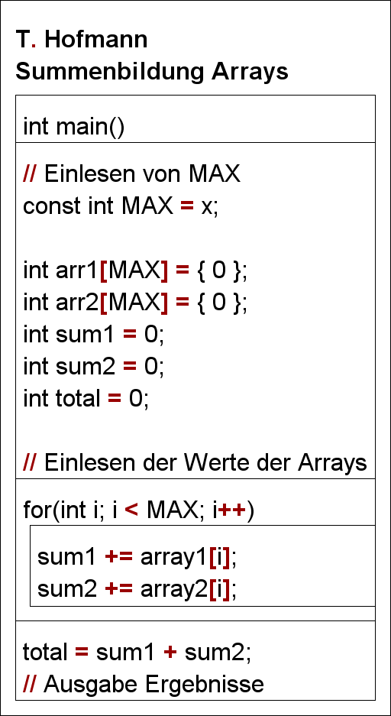array1 = {1, 2, 3, 4, 5}  
array2 = {6, 7, 8, 9, 10}

|  |  |  |  |  |  |
| --- | --- | --- | --- | --- | --- |
| array1[i] | array2[i] | Sum1 | Sum2 | total | For i < 5 |
| 0 | 0 | 0 | 0 | 0 | - |
| 1 | 6 | 1 | 6 |  | T |
| 2 | 7 | 3 | 13 |  | T |
| 3 | 8 | 6 | 21 |  | T |
| 4 | 9 | 10 | 30 |  | T |
| 5 | 10 | 15 | 40 |  | T |
|  |  | 15 | 40 | 55 | F |

# Summenbildung bei geraden und ungeraden Zahlen

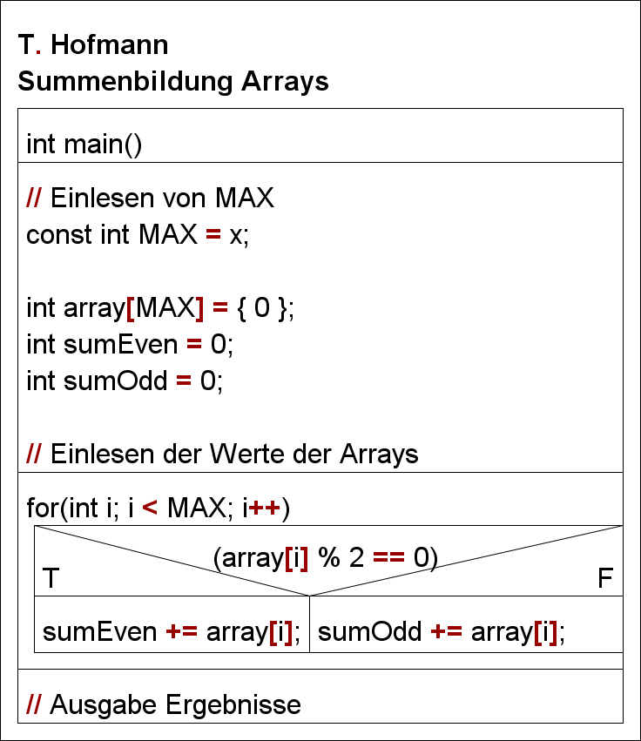array = {1, 2, 3, 4, 5, 6, 7, 8, 9}

|  |  |  |  |  |
| --- | --- | --- | --- | --- |
| Array[i] | sumEven | sumOdd | for i < 9 | if |
| - | 0 | 0 | - | - |
| 1 |  | 1 | T | T |
| 2 | 2 |  | T | T |
| 3 |  | 4 | T | F |
| 4 | 6 |  | T | T |
| 5 |  | 9 | T | F |
| 6 | 12 |  | T | T |
| 7 |  | 15 | T | F |
| 8 | 20 |  | T | T |
| 9 |  | 24 | T | F |
| - | 20 | 24 | F | - |